**Christmas will soon be here**

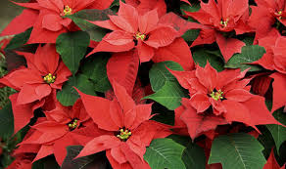If you would like to order poinsettia plants to decorate the sanctuary on Christmas, please fill out this form and drop it and your payment in the offering plate. If you wish, you may mail the form or deliver it to the church office with your check. Deadline: Wednesday, December 18th .

**Price per plant is: $20** (checks made payable to Hingham   
Congregational Church, memo line: Christmas Plants)

-----------------------------------------------------------------------------I would like to order:______________ poinsettia plant(s)

Check enclosed in the amount of $___________________

**In loving memory of:**

_______________________________________________

**In honor of:**

_______________________________________________

**In celebration of:**

_______________________________________________

**Given by:** (optional)

_______________________________________________

**Christmas will soon be here**

If you would like to order poinsettia plants to decorate the sanctuary on Christmas, please fill out this form and drop it and your payment in the offering plate. If you wish, you may mail the form or deliver it to the church office with your check. Deadline: Wednesday, December 18th .

**Price per plant is: $20** (checks made payable to Hingham   
Congregational Church, memo line: Christmas Plants)

-----------------------------------------------------------------------------I would like to order:______________ poinsettia plant(s)

Check enclosed in the amount of $___________________

**In loving memory of:**

_______________________________________________

**In honor of:**

_______________________________________________

**In celebration of:**

_______________________________________________

**Given by:** (optional)

_______________________________________________